# Compass - Pharmacy Details

Pharmacy Details Screen

Related Documents

**Description:** Information found on the Pharmacy Details screen in Compass.

|  |
| --- |
| Pharmacy Details Screen |

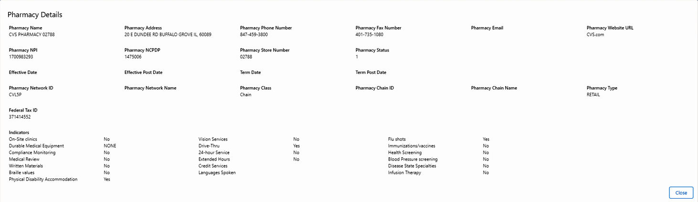

The below table provides a list of fields and their descriptions most used by PHD agents:

|  |  |
| --- | --- |
| **Field** | **Description** |
| **Pharmacy Name** | Name of the pharmacy |
| **Pharmacy Address** | Street address of the pharmacy |
| **Pharmacy Phone Number** | Phone number for the pharmacy |
| **Pharmacy Fax Number** | Fax number for the pharmacy |
| **Pharmacy NPI** | Identifies the National Provider Identifier for the pharmacy |
| **Pharmacy NCPDP** | Identifies the National Council for Prescription Drug Programs number |
| **Pharmacy Store Number** | Identifies the Store number associated with the pharmacy in their chain |
| **Pharmacy Network Name** | Identifies the name ofthe network to which the pharmacy belongs |
| **Pharmacy Class** | Identifies the class of pharmacy; Chain, Affiliate, Independent |
| **Pharmacy Chain Name** | Identifies the name of the pharmacy chain; CVS, Publix |
| **Pharmacy Type** | Identifies the type of pharmacy; Retail, Mail |

Top of the Document

|  |
| --- |
| Related Documents |

**Parent Document:** [CALL-0049 Customer Care Internal and External Call Handling](https://policy.corp.cvscaremark.com/pnp/faces/DocRenderer?documentId=CALL-0049)

Top of the Document

Not to Be Reproduced or Disclosed to Others without Prior Written Approval

**ELECTRONIC DATA = OFFICIAL VERSION / PAPER COPY = INFORMATIONAL ONLY**